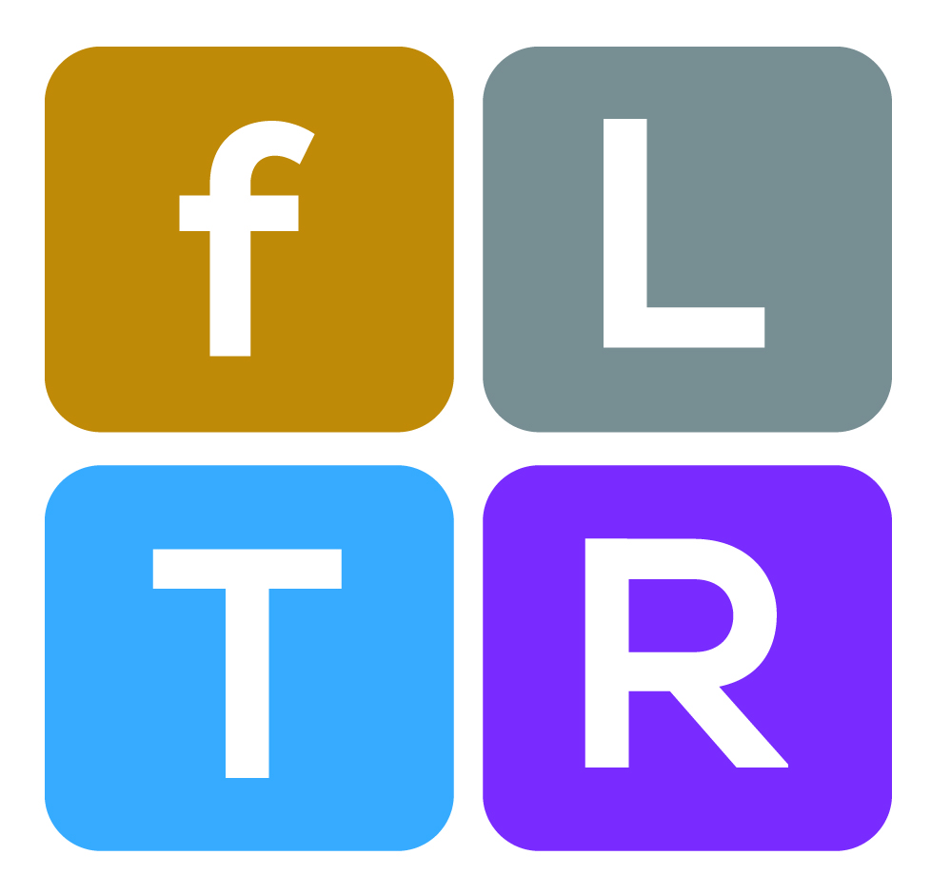

Certificate Course on
Teaching for Active Learning (TAL: Batch 5): An Initiative of fLTR
==================================================

“It is the supreme art of the teacher to awaken joy in creative expression and knowledge.”
- Albert Einstein

“The test of a good teacher is not how many questions he can ask his pupils that they will answer readily, but how many questions he inspires them to ask him which he finds it hard to answer.”
-Alice Wellington Rollins
Introduction
With increased recognition that skilled teachers are perhaps the most fundamental resource for improving student learning, there is growing interest in figuring out how to recruit and retain competent teachers, especially in private universities of Bangladesh. Evidence shows that high quality teachers play an important role in facilitating interactive teaching and learning. So attracting the best people to teach in the higher education is a great challenge. Moreover, getting them to stay in teaching profession is even more important. But ensuring both of these is really a challenge for private universities in Bangladesh.
Ensuring quality teaching and learning has become an issue of importance as the landscape of higher education in Bangladesh has been facing continued changes: increased competition, increasing social and geographical diversity of the student body, increasing demands for value of money, introduction of Information, Communication and Technologies (ICT), etc. Modern educational technologies have entered the classroom and demand the appropriate interactions between students and teachers. Effective teachers have empathy for students, they are organized and expressive. They have passions for learning, for their field, for teaching and for their students. But research also demonstrates that effective teaching depends on what is being taught and on other situational factors.
The Foundation for Learning, Teaching and Research (fLTR), which has been recently created by nine Vice Chancellors of private universities, has taken an initiative to offer a certificate course on Teaching and Learning designed especially for the new instructors of private/public universities of Bangladesh. The course will be facilitated on workshop mode and will run for three full working days (3 days X 8 hours=24 hours) which deals with fundamental requirements for teaching and learning at the university level. However, the fLTR is also planning to offer a long duration Diploma course both on teaching, learning and research.
It is commonly observed that while the new instructors are comfortable with their subject matter, but to be successful teachers for effective classroom teaching, they need more support for ensuring quality teaching and learning. The new instructors ( through a survey conducted earlier) expressed that they believed there was a “generation gap” between them and their students, and they wanted to have a better understanding of the students and the way they think, act and express themselves.
The founders of fLTR strongly felt that the newly recruited faculty members must be oriented about the teaching philosophy, organizational culture, values and academic teaching and non-academic management practices of the university. So the agenda for the program was developed based on the new instructors’ needs.

Major focus: Promoting professionalism in teaching for facilitating interactive teaching and learning.

Course Objectives: On completion of the course the participants are expected to:
- Have deeper comprehension on the concepts of active learning, teaching, facilitation and learning, pedagogy and andragogy
- Elaborate the underlying factors of teaching for active learning.
- Identify the learning domains of Bloom’s Taxonomy and explain their application in formulating course objectives and learning outcomes.
- Define the behaviors of high performing teachers which help to create a comfortable learning environment for the learners.
- Describe behavioral ethics in teaching and learning.
- Integrate social capital (class norms) in classroom teaching and learning for creating conducive learning environment.
- Manage the disruptive behavior of the students.
- Formulate quality questions focusing on different learning domains of Bloom’s Taxonomy
- Prepare a learner centered course syllabus and lesson plan.
- Explain the process of performance assessment of learners used in the higher education.

Learning Outcomes: On completion of the course the participants will beprepared to:
- Apply social capital in their teaching and learning
- Use interactive methods, tools and techniques in teaching and learning
- Demonstrate high performing habits and behaviors
- Identify the learning needs and styles of the learners
- Formulate quality questions based on learning domains
- Develop learner centered course syllabus and lesson plan
- Use formative and summative evaluation for assessing the performance of the learners
- Deal with disruptive behavior of the learners

Contents:
Social Capital: Ground Rules for Effective Classroom Teaching and Learning
Teaching in Higher Education: Bigger Picture of Education
Pedagogy and Andragogy
Principles of interactive teaching and learning
Teaching styles Vs Learning styles (Multiple Intelligences)
The Art of Questioning
Course Objectives and Students Learning Outcomes
The Art of Receiving and Giving Constructive Feedback
ICT in Teaching
Effective Habits and Behaviors of High Performing Teachers
The Art of Preparing Quality course Syllabus
Preparing Effective Lesson Plan
Behavioral Ethics in Teaching and Learning
Grading Students’ Performance
Teaching Portfolio
Management of Disruptive Behavior of the Students

Prepared for
The course has been designed for the newly recruited teachers (Lecturer/ Senior Lecturer/ Assistant Professor) of both private and public universities. It is expected that a group of 30-35teachers will attend the course.

Eligibility Criteria: Teachers of both private and public universities (lecturers/ Senior Lecturer/ Assistant Professor)

Duration: Three full working days (3 days x 8 hours= 24 hours): 9 am to 5 pm (In the first day the participants should come at 8:30 am)

Course offering date: 30-31 August & 1st September 2018
Course Fees : Tk. 10000 (Ten Thousand Taka only)

Methods, Tools and Techniques:
The following interactive teaching and learning methods, tools and techniques will be used.
Lecture –Discussion
Micro- teaching
Group Exercise
Plenary session
Simulation Exercise
Learning Partner
Colloquium
Learning Reflection

Reading Materials: A Course Pack which will include relevant and required readings will be prepared for the course.

Course Director: Prof. Md. Golam Samdani Fakir, Vice Chancellor of Green University

Certificate for the Course: All participants who will successfully complete the course will receive a certificate.

Pre-course and Post course Assessment: A structured format will be used to assess the pre- and post-course knowledge and skills on teaching and learning

Course Evaluation: Both formal and informal reaction level evaluation will be conducted.

Course Venue: Ahsanullah University of Science and Technology (AUST), 141 & 142, Love Road, Tejgaon Industrial Area, Dhaka-1208.

Course Facilitation Team: Members of Green University Center of Excellence in Teaching and Learning (GUCETL)

Application Procedure: University authorities (both public and private) should nominate their candidates (maximum two), who are preferably newly recruited Lecturer, Senior Lecturer and Assistant Professor, using the prescribed registration form attached. Completed registration form is to be submitted at fLTR, Office, 220/D Begum Rokeya Sarani, Dhaka 1207, Green University of Bangladesh by 15 August, 2018

Application can also be sent through e-mail at hasan.gucetl@green.edu.bd or motiur.pro@green.edu.bd

Admission & Course Fees: Application will be reviewed on rolling basis (first apply first call). Each candidate will have to pay total Tk. 10,000/ as course fees. Money could be deposited at Account Name: Foundation for Learning, Teaching and Research, A/C # 11011024703, Dutch Bangla Bank.

Secretariat of fLTR
220/D Rokeya Sarani, Dhaka 1207
Green University of Bangladesh
Cell #01671642515 or 01719130339

