Final Reflection
On
The Certificate Course on Teaching for Active Learning (TAL-4)

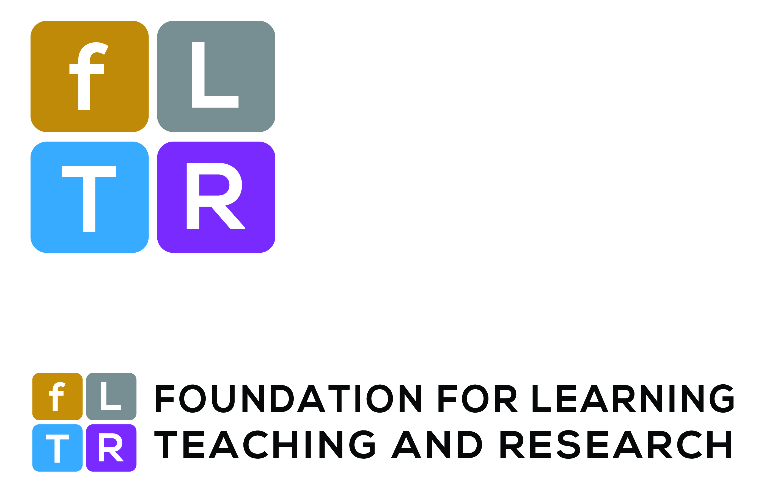

By
Md. Ashraful Goni
Lecturer
Department of Mass Communication and Journalism
Bangladesh University of Professionals (BUP)

“I never teach my pupils, I only attempt to provide the conditions in which they can learn.” - Albert Einstein

When I start teaching, I was highly motivated by those words of Albert Einstein. I always try to create a situation where the student will keen to learn. I was looking for ways, how I can make it happen. In the very first day of “The Certificate Course on Teaching for Active Learning” (TAL) I learned about Andragogical teaching method. I do realize it is not only me who is fed up with the so-called Pedagogical teaching methods. There are some other people who are in the tune of changing teaching methodology. In my student life I often ask a question, Since the very inception of our formal study we are learning English language but studying for at least 12 or 13 years most of us are unable to speak fluently in English. Why this is happening with us. There must be some problem with our education system. After the training program, I got my answer. In our country, we are only focusing on the passive learning, not in the active learning. After learning about Bloom’s Taxonomy, I can say that we are giving more emphasis on the lower order of learning rather than higher order of learning.
The debate on Pedagogy and Andragogy was the most enjoyable part of day one. In day two I like the Idea of “Teaching portfolio” and also learn how to manage disruptive behavior in the classroom. In the very last day the “The Art of Preparing Quality Course Syllabus and Lesson Plan” and “Formulating Quality Questions Based on Learning Domains of Bloom’s Taxonomy” both of the session was amazing.

I think an analysis of pre-test and post-test answer script will tell the summary of the entire course. I remember, in the pre-test I was nervous and I was able to answer only 4-5 questions. I believe everyone else faces the same situation. On the last day when we took the exact same test, I was confident and I was able to answer all the question on time. This clearly shows how much we have learned in the shortest period of time.
It’s my pleasure and privilege to take part in the Certificate Course on Teaching for Active Learning (TAL-4) held on 5-7 April 2018 organized by Foundation for Learning, Teaching, and Research (FLTR). My Gratitude’s towards Prof. Dr. Md. Golam Samdani Fakir sir. He is an excellent facilitator to follow on. I have learned so many things from his facilitating style.
I think the best part of the training was the opportunity to socialize with the 22 intellectuals from 13 different universities both from public and private. I like the concept of learning partner. I think this sort of gathering is always helpful to increase anyone’s knowledge.
In conclusion I want to say that , this is the era of technological advancement. Technology has made life easier but increasingly competitive. Every day, we are running after the success that can be measured with the substantial gain. I think this training gave me the courage to live in the atmosphere of the highly competitive world.

